# Attendance Marking System Using Face Recognition

Submitted to

# LOVELY PROFESSIONAL UNIVERSITY PHAGWARA, PUNJAB



Master of Computer Application

Submission Date: **2nd Oct, 2022**

Submitted By: Submitted to:

**Suraj Vishwakarma ( 12115712 ) Girish Kumar**

# To whom so ever it may concern

I, **Suraj Vishwakarma (12115712)** hereby declare that the work done by us on “**Attendance Marking System using Face Recognition**” in the month of **October 2022**, **Lovely** **Professional University**, **Phagwara**, **Punjab**, is a record of original work for the partial fulfillment of the requirements for the award of the degree, **Master of Computer Application.**

**Suraj Vishwakarma ( 12115712 )**

Dated: 28th Oct, 2022

**Table of Contents**

|  |  |  |
| --- | --- | --- |
| **Sr. No.** | **Title** | **Page No.** |
|  |  |  |
| 1 | Introduction: | 5 |
|  | 1. Introduction to Facial Recognition | 5 |
| 2 | Motivation: | 6 |
| 3 | Review of Literature: | 6 |
| 4 | Proposed Solution: | 8 |
|  | 1. Proposed System Components | 8 |
|  | 1. Proposed System Outcomes | 8 |
| 5 | Usability: | 8 |
| 6 | Project Plan: | 9 |
|  | 1. Objective | 9 |
|  | 1. Goals | 9 |
| 7 | Methodology: | 9 |
| 8 | Data Acquisition: | 10 |
|  | 1. Image acquisition | 10 |
|  | 1. Dataset Creation | 10 |
|  | 1. Storing | 10 |
|  | 1. Attendance Marking | 10 |
| 9 | Face Recognition Procedure: | 10 |
|  | 1. Face Detection and Extraction | 11 |
|  | 1. Face Positioning | 11 |
|  | 1. Face Encoding | 11 |
|  | 1. Face matching | 11 |
| 10 | Methods and Materials: | 11 |
|  | 1. Tools and Technologies | 11 |
|  | 1. Python | 11 |
|  | 1. OpenCV | 12 |
| 11 | Technology Used: | 12 |
| 12 | Requirements: | 12 |
|  | 1. Technical Requirements: | 12 |
|  | 1. Hardware Requirements | 12 |
|  | 1. Software Requirements | 13 |
|  | 1. Functional Requirements: | 13 |
|  | 1. Non-Functional Requirements | 13 |
|  | 1. Student Requirements | 14 |
|  | 1. Teaching Requirements | 14 |
| 13 | FlowChart: | 14 |
| 14 | Result and Conclusions: | 15 |

1. **Introduction:**

Every organization requires a robust and stable system to record the attendance of their students. and every organization have their own method to do so, some are taking attendance manually with a sheet of paper by calling their names during lecture hours and some have adopted biometrics system such as fingerprint, RFID card reader, Iris system to mark the attendance. The conventional method of calling the names of students manually is time consuming event. The RFID card system, each student assigns a card with their corresponding identity but there is chance of card loss or unauthorized person may misuse the card for fake attendance. While in other biometrics such as finger print, iris or voice recognition, they all have their own flaws and also they are not 100% accurate. Use of face recognition for the purpose of attendance marking is the smart way of attendance management system. Face recognition is more accurate and faster technique among other techniques and reduces chance of proxy attendance. Face recognition provide passive identification that is a person which is to be identified does not to need to take any action for its identity. Face recognition involves two steps, first step involves the detection of faces and second step consist of identification of those detected face images with the existing database. There are number of face detection and recognition methods introduced. Face recognition works either in form of appearance based which covers the features of whole face or feature based which covers the geometric feature like eyes, nose, eye brows, and cheeks to recognize the face. Our system uses face recognition approach to reduce the flaws of existing system with the help of machine learning, it requires a good quality camera to capture the images of students, the detection process is done by histogram of oriented gradient. And recognizing perform through deep learning. The frontend side (client side) which consist of GUI which is based on electron JS and backend side consist of logic and python (server side), an IPC (Inter Personal Communication) bridge is developed to communicate these two stacks. The images capture by the camera is sent to system for further analysis, the input image is then compared with a set of reference images of each of the student and mark their attendance.

* 1. **Introduction to Facial Recognition:**

A person’s face has distinctive physical shape and characteristics that are used to identify or verify an individual. Facial recognition records this biometrics of the face. Different face recognition methods measure the biometric of the face. Facial recognition has become a very important topic in recent years. Facial recognition is effectively applied in various applications like security systems, authentication, entrance control, surveillance system, unlocking of smartphones and social networking systems, etc. Most of the practices do not use facial recognition as the main form of conceding entry. However, with advancement in technology and algorithm, facial recognition system has the potential to replace the standard passwords and fingerprint scanners. [1] This project was carried out to show how a Local Binary Pattern Histogram (LBPH) face recognizer could be used for taking attendance of students. LBPH facial recognizer is a pre-trained facial recognition classifier. If enough data set are available on the face that is needed to be identified, LBPH can perform facial recognition with high accuracy. Face Recognition Student Attendance System is a desktop application that identifies and verifies student’s identities with the help of a digital image. Once the recognized face matches with the stored image, the attendance is completed and marked in the database for the student. This system will provide an alternative and easier way of taking attendance.

The facial recognition system has three main phases, which are described below:

**Face Detection:**

Face detection is the ability to identify the person’s faces within the digital images. This system identifies the human face present in an image or video. We need to define a general structure of a face to determine certain picture or 4 video contains a face (or several). Human faces have the same features such as eyes, nose, forehead, mouth, and chin. Therefore, the objective of face detection is to find the location and size of the face in an image. The located face is then used by the facial recognition algorithm.

**Feature Extraction:**

In this phase, we are extracting the features from the detected face. In LBPH, the first local binary pattern images are computed, and a histogram is created for facial recognition. This generates a template. A template is a set of data that represents the unique and distinctive features of the detected face.

**Face Recognition:**

Face Recognition is being able to uniquely identify and verify a person’s face by comparing and analyzing a biometrics person’s face. A face recognition system is an application that is used for identifying or verifying a person from a digital image.

1. **Motivation /Purpose:**

The main motivation for this project was the slow and inefficient traditional manual attendance system. So, why not make it automated fast and much efficiently. Also, such face detection techniques are in use by the department of a criminal investigation where the usage of CCTV footages and detecting the faces from the crime scene and comparing them with criminal database to recognize them. It is also becoming as a features of daily life in China, where authorities are using it on the streets, in subway stations, and at airports.

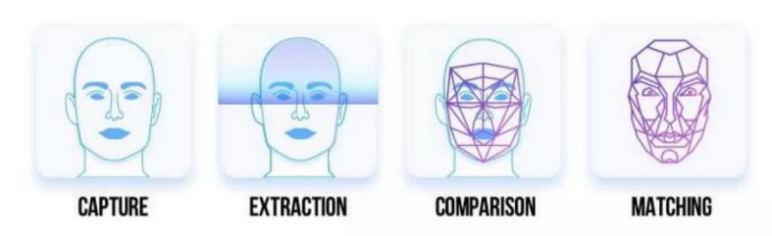

1. **Review of Literature:**

Face Recognition is such a challenging yet interesting problem that it has attracted researchers from different backgrounds. It is due to this fact that the literature on face recognition is vast and diverse. The earliest work on face recognition can be traced back at least to the 1950s additionally; the research on automatic machine recognition of faces really started in the 1970s, but a fully automatic face recognition system based on a neural network was reported back in 1997.

The aim of all the research was to make face recognition as automated and accurate as possible through various types of inputs such as static images, video clips, etc. so as to increase its applications in real world. These types of difficulties appear because faces are need to be represented in such a way that best utilizes the available face information to define a specific face from all the other faces in the database. Also, extracting such detailed facial features can be used in slandering the search and enhancing recognition.

The problem of automatic face recognition involves three key steps:

1. Face Detection
2. Feature Extraction
3. Recognition

Sometimes, the steps are not totally separated. For Example, the facial features used for face recognition are often used in face detection. Face detection and feature extraction can be achieved simultaneously. Other than that accuracy depends on various factors such as, the nature of the application, size of the training and testing database, clutter and variability

Of the background, noise, occlusion, and computing requirements, etc. and a fully automatic face recognition system needs to perform all the three steps accurately.

It’s evident that after more than 30 years of research and development, basic 2D face recognition and other image processing applications have reached a mature level and many commercial systems are available for various applications. Some of the major reasons for this success are faster computers, algorithmic improvements, access to large amounts of research tools and datasets, advances in machine learning and perception, the increase in affordable neural networks and now the data-hungry deep learning methods, which have started to dominate accuracy benchmarks around 2011. Various surveys also present factual data indicating that error rates in image processing tasks have fallen significantly since 2012 and are expected to for fall further in near future.

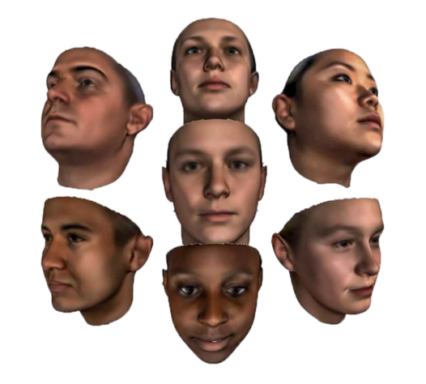

1. **Proposed Solution:**

To overcome the problems in the existing attendance system we shall develop a Biometric based attendance system over simple attendance system. There are many solutions to automate the attendance management system like thumb-based system, simple computerized attendance system, Iris scanner, but all these systems have limitations overwork and security point of view. Our proposed system shall be a “Attendance Marking System Using Face Recognition” which uses the basic idea of image processing, which is used in many security applications like banks, airports, intelligence agencies etc.

4.1 **Proposed System Components:**

1. Following are the main components of the proposed system:
2. Student Registration using a form created with the help of tkinter.
3. Face Detection.
4. Face Recognition.
   * 1. -Feature Extraction
     2. -Feature Classification
5. Attendance Marked and Save the student's detail in an excel file with their name, time an date for later use.

**4.2 Proposed System Outcomes:**

* It will mark attendance of the students via face Id.
* It will detect the faces via wireless camera(IP Camera)/webcam and then recognize the faces.
* After the recognition, it will update the student’s attendance record in a csv file.
* The admin will be able to print these records details afterward.
* Ease the process of taking boring yet important task i.e. attendance.

1. **Usability/Project Contribution:**

Face recognition is the most natural biological features recognition technology, according to the cognitive rule of human beings; its algorithm is ten times more complex than a fingerprint algorithm. The system will do its work even if one is not in touch with or forget about it.

Face recognition is featured by the following advantages compared to fingerprint:

1. **Accurate and Fast Identification**

Industrial Leading Facial Recognition Algorithm, matches more data than a fingerprint FAR<0.0001%

1. **High Usability and Security**

Failure to enrol and acquire rate is less than 0.0001%, fingerprint technology will have problems for enrollment with cold, wet, desquamation, elder, and around 5% people cannot get enrolled with a photo which is captured by the camera, there is no evidence with fingerprint technology to track the incident.

1. **User friendly design**: Contactless authentication for ultimate hygiene.
2. **Project Plan:** 
   1. **Objectives:**

* Detection of unique face image amidst the other natural components such as walls and other backgrounds.
* Detection of faces amongst other face characters such as beard, spectacles etc.
* Extraction of unique characteristics features of a face useful in face recognition.
* Effective recognition of unique faces in a class (individual recognition)
* Automated updated in the attendance sheet without human intervention.
* To keep the student updated with their attendance ratio.
  1. **Goals:**
* To help the lecturers, improve and organize the process of tracking and managing student attendance.
* Provides a valuable attentive service for both teachers and students.
* Reduce manual process errors by providing automated and a reliable attendance system.
* Increase privacy and Security which, student cannot present him or his friend while they are not.
* Produce monthly reports for lecturers.
* Flexibility, lectures capability of editing attendance records.
* Reduce time loss as time is a very valuable resource.

1. **Methodology:**

The proposed system is designed for automating the attendance of the different organization and reduces the flaws of existing manual system. The system calculate the attendance subject wise, that is the data of students and subjects are added manually by administrator, and whenever time for corresponding subject arrives the system automatically starts taking snaps and find whether human faces are appear in the given image or not. We have used Histogram of Oriented Gradient for face detection and deep learning techniques to calculate and compare 128-d face features for face recognition. Once faces are detected and recognize with the existing database, system calculate attendance for the recognize students with the respective subject id in real time. And an excel sheet generated and saved by the system automatically.

1. **Data Acquisition:**
   1. **Image acquisition:**

Image is acquire using a high-definition camera which is placed in the classroom. This image is given as an input to the system.

**8.2 Dataset Creation:**

Dataset of students is created before the recognition process. Dataset was created only to train this system. We have created a dataset of 5 students which involves their name, roll number, department, and images of student in different poses and variations. For better accuracy minimum 15 images of each students should be captured. Whenever we register student’s data and images in our system to create dataset, deep learning applies to each face to compute 128-d facial features and store in student face data file to recall that face in recognition process. This process is applying to each image taken during registration.

**8.3 Storing:** We have used CSV file to store the student’s data.

**8.4 Attendance Marking:**

Once the face is identified with the image stored in the folder, python the date and time and name of the students and return that, when data is returned, the system saves these data into a csv file for later use. And then passes the data to python to store the table into an excel sheet automatically.

1. **Face Recognition Process:**

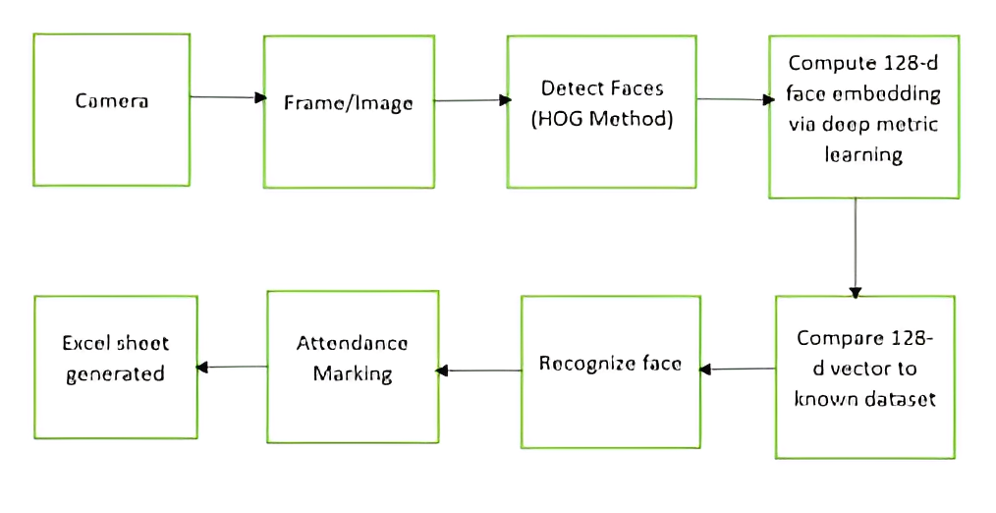

**9.1 Face Detection and Extraction:**

Face detection is important as the image taken through the camera given to the system, face detection algorithm applies to identify the human faces in that image, the number of image processing algorithms are introduce to detect faces in an images and also the location of that detected faces. We have used HOG method to detect human faces in given image.

**9.2 Face Positioning:**

There are 68 specific points in a human face. In other words we can say 68 face landmarks. The main function of this step is to detect landmarks of faces and to position the image. A python script is used to automatically detect the face landmarks and to position the face as much as possible without distorting the image.

**9.3 Face Encoding:**

Once the faces are detected in the given image, the next step is to extract the unique identifying facial feature for each image. Basically whenever we get localization of face, the 128 key facial point are extracted for each image given input which are highly accurate and these 128-d facial points are stored in data file for face recognition.

**9.4 Face matching:**

This is last step of face recognition process. We have used the one of the best learning technique that is deep metric learning which is highly accurate and capable of outputting real value feature vector. Our system ratifies the faces, constructing the 128- d embedding (ratification) for each. Internally compare faces function is used to compute the Euclidean distance between face in image and all faces in the dataset. If the current image is matched with the 60% threshold with the existing dataset, it will move to attendance marking.

1. **Methods and Materials:**

This is the most important section of the project. This section describes the detailed workflow of the project and the necessary theoretical background.

**10.1 Tools and Technologies:**

Tools and Technologies Tools and techniques used in the project are described in this section of the thesis. This project focused was mainly focused on Python Programming and its libraries.

**10.1.1 Python:**

Python is a high-level object-oriented programming language. It was created by Guido van Rossum in 1991 as Python 0.9.0. It was created as the successor of the ABC programming language. Python 2.0 was released on 16 October 2000 and added many features like list comprehension and garbage collecting system. On 3 December 2008, Python 3.0 was released. Python is a very popular programming language and can be used for various purposes. It is widely used for web development, software development, mathematics and data analysis, system scripting, etc. Python is a multi-purpose programming language that works on different platforms like Windows, Linux, Mac, Raspberry Pie, etc. Python is popular than other programming languages because it has a simple syntax than other programming languages. Its syntax allows the programs to write code that is easier to understand and in fewer lines. It runs in an interpreter system. Hence, the code can be executed as soon as it is written. In this project, we use Python for web development. This project demonstrated how Python is used for an effective and reliable web application. Various Python frameworks, libraries are used in this project.

**10.1.2 OpenCV:**

OpenCV is an open-source machine learning and computer vision library. OpenCV is a cross-platform library and is free to use. It was launched in 1999. Intel launched OpenCV to advance CPU-intensive applications. It was developed in C++. It provides bindings for Java and Python programming languages. It runs in different operating systems such as Linux, Windows, OSx, etc. It focuses mainly on video capturing, image processing, and analysis. It has face detection 15 and objects detection features. OpenCV can be used to read and write images and capture and save videos. It can perform feature detection like faces, cars, images, etc. Many established companies like Yahoo, Google, Microsoft, Intel, and many others use the library.

1. **Technology Used:**

The following tools used while making this project.

* OpenCV for Opensource Computer vision.
* Face Recognition Library for Recognition of face and use of HOG algorithms.
* Python Programming language to run this concept of facial recognition.
* Jupyter Ide to run and implement the project in python.
* Webcam/Laptop Camera can also be used.

1. **Requirements:**
   1. **Technical Requirements:**
      1. **Hardware Requirements:**

* A standalone computer (i3 7th Gen, 8GB Ram or higher)
* High-Quality wireless camera to capture images
* Secondar memory to store all the images and database.
  + 1. **Software Requirements:**
* Jupyter Notebook 4.1 or higher
* Python 3.5 or higher
* Windows 8 or higher
* Latest version of all libraries.
  1. **Functional Requirements:**

System Functional requirement describes activities and services that must provide.

* A user must be able to manage student records.
* An only authorized user must be able to use the system.
* A system must be attached to wireless camera and face recognition should be smooth.
* The administrator or the person who will be given the access to the system must login into the system before using it.
* The information must be entered and managed properly.
  1. **Non-Functional Requirements:**

Non-Functional Requirements are characteristics or attributes of the system that can judge its operation. The following points clarify them:

1. Accuracy and Precision: The system should perform its process with accuracy and precision to avoid problems.
2. Flexibility: The system should be easy to modify, any wrong should be correct.
3. Security: The system should be secure and saving student’s privacy.
4. Usability: The system should be easy to deal with and simple to understand.
5. Maintainability: The maintenance group should be able to cope up with any problem when occurs suddenly.
6. Speed and Responsiveness: Execution of operations should be fast.

Non-Functional Requirements are as follows:

* The GUI of the system will be user-friendly.
* The data that will be shown to the user will be made sure that it is correct and is available for the time being. The system will be flexible to changes.
* The system will be extended for changes and to the latest technologies.
* Efficiency and effectiveness of the system will be made sure.
* The performance of the system will be made sure.
  1. **Student Requirements:**
* A student needs to enter the proper details while registering him/her.
* He/She needs to sit properly and capture 10-15 images of himself/herself in different directions and expressions.
* At the time of taking attendance, students need to sit properly facing the camera.
  1. **Teaching Requirements:**
* The Faculty needs to log into the system at the time of attendance.
* The Faculty needs to enter lecture details before starting the attendance process.
* If the entered lecture details don’t match with the ones in the database (excel sheet) an error dialog will be displayed.

1. **FlowChart:**

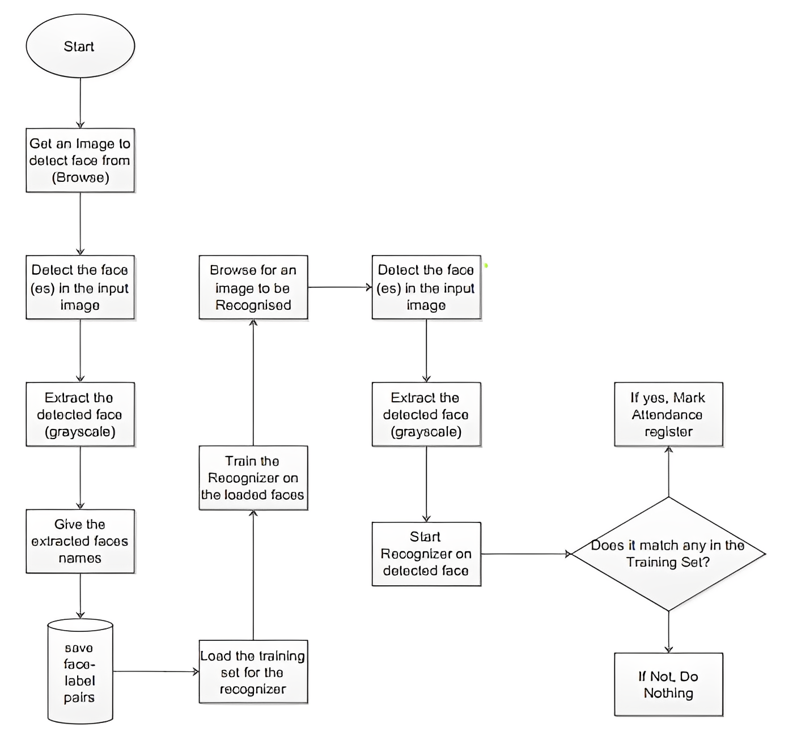A graphical representation of a computer program in relation to **the** sequence of **its** functions (as **opposed** **to** the data it processes).

1. **Result and Conclusions:**

**Attendance Marking System using Face Recognition** is designed to solve the issues of existing manual systems. We have used face recognition concept to mark the attendance of student and make the system better. The system performs satisfactory in different poses and variations. In future this system need, be improved because these system sometimes fails to recognize students from some distance, also we have some processing limitation, working with a system of high processing may result even better performance of this system.